

**HO CHI MINH CITY, 05/07/2020**

**FINAL REPORT**

**DATA PROCESS AND OBJECT MODELLING**

**ONLINE GORCERY SHOPPIGN**

**VIETNAM NATIONAL UNVERISITY HCMC**

**UNIVERSITY OF INFORMATION TECHNOLOGY**

**SCHOOL OF INFORMATION SYSTEMS**

Instructor: MSc. Trinh Trong Tin

Students:

Nguyễn Quốc Đại 17521294

Nguyễn Thanh Đức 17521295

**ACKNOWLEDMENTS**

Presentation inspiration and motivation have always played a key role in the success of any venture.

We would like to express our special gratitude and thanks to our adviser, MSc. Trinh Trong Tin for imparting her knowledge and expertise and his useful and constructive recommendations on this project.

Ho Chi Minh City, 06 July 2020

Group of students

**INSTRUCTOR COMMENTS**

**…………………………………………………………………………………………………………………………………………………………………………………………………………………………………………………………………………………………………………………………………………………………………………………………………………………………………………………………………………………………………………………………………………………………………………………………………………………………………………………………………………………………………………………………………………………………………………………………………………………………………………………………………………………………………………………………………………………………………………………………………………………………………………………………………………………………………………………………………………………………………………………………………………………………………………………………………………………………………………………………………………………………………………………………………………………………………………………………………………………………………………………………………………………………………………………………………………………………………………………………………………………………………………………………………………………………………………………………………………………………………………………………………………………………………………………………………………………………………………………………………………………………………………………………………………………………………………………………………………………………………………………………………………………………………………………………………………………………………………………………………………………………………………………………………………………………………………………………………………………………………………………………………………………………………………………………………………………………………………**

**…………………………………………………………………………………………**

**TABLE OF CONTENTS**

**ACKLOWLEDMENTS**

I. INTRODUCTION 1

*1. INTRODUCTION* 1

2. STATEMENT OF THE PROBLEM 2

3. PURPOSE OF THE STUDY 2

4. LIMITATIONS 6

5. RESEARCH METHODOLOGY 7

II. PROJECT SURVEY 8

III. REQUIREMENTS 10

1. Company organizational chart 10

2. Functional requirements 10

A. Use case diagram 11

B. Use case description 11

1. Administrator Create Item 11

2. Administrator Update item 12

3. Administrator Delete Item 13

4. Administrator Searching for orders 14

5. Administrator View Order Details 14

6. Administrator Update Order Status 15

7. Adding to Shopping cart 16

8. Search Item by Key-word 17

9. View Item Details 18

10. Giving Comment on an Item 19

11. Searching Order 20

12. Making Order 21

C. Mockup/Wirefram*Main Home Page 23

1. View Item Details 24

2. Create new Items 25

3. View Shopping cart 26

4. Checkout page 27

5. Update item 28

6. Administrator Page 29

D. Business process. 30

1. User Activity Diagram 30

2. Admin Activity Diagram: 31

3. Admin create item Activity Diagram 32

4. Admin update Item information 33

E. Non-functional requirements 33

IV. DESIGN SPECIFICATION 34

1. Project Overview 34

2. Database Design 34

3. All use case 39

A. Search items by key word 39

B. Search items by Category 41

C. View Item Detail 43

D. Add item to cart 45

E. Making order 47

F. View Shopping Cart 49

G. Making comment in an specify item 49

H. Update user account profile 51

I. Adding Shipping Address 52

K.Administrator Create Item 54

L. Administrator Update Item 56

M. Administrator Delete Item 57

N. Administrator Searching order 58

O. Administrator View Order detail 60

P. Administrator Update order 62

V. DEMONSTRATION 63

1. System configuration 63

2. Screenshots 63

VI. SUMMARY 70

# INTRODUCTION

## 1. INTRODUCTION

- In the Coronavirus disease now,going to the grocery store might not be possible for everyone (those watching the kids or those unable to leave the house, for instance),it is very dangerous if we go outside to buy groceries.So the solution for this problem is Online grocery shopping .

- Changing from shopping at the supermarket to online grocery shopping can support social distancing and avoid contracting coronavirus ,It also can improve an online grocery retailer’s productivity by shortening supply chains, reducing overhead costs, and enabling “just in time” service.Most grocery store chains offer online shopping options with free in-store pickup; a few even offer home delivery for a small fee. In HCM CIty,Viet Nam , which are currently in nationwide social distancing ,people in here need an system for buying grocery without coming out of their home.

- Every organization ,whether big or small,has challenges to overcome and manage the information of Customer ,Grocery,Stock,Address,Items.Every Online Grocering system has different grocery needs,therefore this system will help us to ensure that our organization is equipped with the right level of information and details for our future goals.

- In this study, the developers develop an online grocery system that will minimize all the effort and time of the customer and to minimize roaming around as well. Therefore, it allows the administrator to track the order of the customer so that they can prepare for it and deliver if needed. Furthermore, in this study, the developer shall create the system that is fully computerized, user-friendly, time effective and well organized.

## 2. STATEMENT OF THE PROBLEM

- Because the corona epidemic is currently very large and serious, it is dangerous to go out to meet or talk to anyone. But food and drink are important to everyone. Therefore, people must go out to buy food and drinks to survive the epidemic. Currently, HCMC has nearly 9 million people and an average of 1 million people will go out every day to buy food and drinks. And supermarkets or groceries are where they go. It's dangerous to have multiple people going to the same store in one season

- Therefore, the online grocery ordering system is the best way available today. People can stay at home and can buy anything online. The system, when launched, will help greatly in preventing illness because people can stay home and order food online. Therefore, the system can significantly reduce the number of people going out every day. Moreover, this system can be reduced to reduce their workload and to make food shopping easier than going to the actual grocery store. Instead of going to the supermarket and going everywhere to find anything, people can stay home and click on whatever they want. In addition, Vietnam is a country with very weak technology so changing everything to shopping online is a good step.

## 3. PURPOSE OF THE STUDY

|  |  |
| --- | --- |
| Research Question | Research hypotheses |
| What payment methods are available? | The customer can pay through credit card and Cash on Delivery or E-Wallet |
| How do customers search for groceries items ? | There will be a search functionality in the main home pages of the app.In the search functionality area there will be a empty text box for typing anything you want to seek,and the results of this search action is all items relate or contain your fill in word |
| Does Customer have their own module ? | Yes,Customer have their own module,and the module for customer allow them to login,log out to the system,place an order,view or extract the order history,update or change their personal information likes their full name , address , phone number for authentication , Default Shipping Address , giving a comment ,a complaint about an item. |
| How can customers add items to their cart? | Customers can add an item to their cart after they chose their wanted items, and select the number of each items if the item are measure by number or select the items mass if the item are measure by weight |
| How can customers Return & Replacements for groceries items ? | In the main home page ,there will be a function for Returning & Replacing groceries item,and this function will ask the customers to fill in a form ,and this form will contain some basic information such as :Kind of form (Return or Replacing ,name of customer,Phone number,address ,order id ( if customer still keep the order),which kind of item that customers need to Return,and description about the reason why customer want to Return or Replacing. |
| Does the system can extract inventory report and sales report. | Yes,the system can do it,if someone logs in to the system as a customer,the customers can view their order history and they also can extract or print it out.  If someone logs in as an admin ,they can also view all inventory report or sales report and extract or print it out |
| Does the Admin can view all transaction records ? | Yes ,the administration can view all transaction records,besides that ,they also can view all the customer ,customer information, all the orders,order information,inventory reports,sales report,.. |
| What is the complete process from placing order to get delivery confirmation/return/exchange on online grocery shopping | First,customers will select an item by search and click on the item at the software ,the system will automatically check for inventory and then show up to the application the Inventory number,or the status of items sold out or not.  After seeking for items ,they will add to their cart and choose the amount of each item.  Then ,customers will start to give shipping location, customer information (in case of these customer want to order for anyone else or they haven’t login yet |

## 4. LIMITATIONS

* System can only cater within HCMC
* The system will be the one to locate the nearest branch
* The customer can’t choose her desire branch
* The system can’t locate the radius of the address on how far the delivery transaction is.
* Limit the number of users accessing at the same time

## 5. RESEARCH METHODOLOGY

* Secondary data is collected from Journals, Articles, and Reports on industry compiled by research companies, Industry websites.
* Sample size of 100 customers and 35 retailers will be collected by way of questionnaire method and the tools used to interpret the primary data will be excel, charts, bar diagrams, and SPSS package will be used up to a certain extent for statistical calculation
* Questionnaire will consist of both open ended and closed ended questions.
* Questionnaire from customers will be collected through online by monkey survey.com
* A literature review will be conducted for finding the reports, magazines, articles and other sources for information on online grocery store

THE DIMENSIONS CONSIDERED FOR ONLINE GROCERY SHOPPING ON THE BASIS OF IMPORTANCE

|  |  |  |  |  |  |  |
| --- | --- | --- | --- | --- | --- | --- |
| **Dimensions** | **1** | **2** | **3** | **4** | **5** | **6** |
| Brands/Products Availability | 36 | 32 | 32 | 0 | 0 | 100 |
| Visibility of Manufactured and Expiry Dates | 51 | 37 | 10 | 2 | 0 | 100 |
| Availability of Stock | 16 | 34 | 42 | 5 | 3 | 100 |
| Quick Delivery | 59 | 34 | 7 | 0 | 0 | 100 |
| Pricing | 54 | 36 | 10 | 0 | 0 | 100 |
| Combo Offers, Discounts and Reductions | 30 | 36 | 32 | 9 | 2 | 100 |
| Credibility | 15 | 32 | 31 | 19 | 3 | 100 |
| Guarantee and Warranty | 17 | 27 | 34 | 15 | 5 | 100 |
| Easy Return Policy | 87 | 13 | 0 | 0 | 0 | 100 |
| Worth for Money | 35 | 55 | 7 | 3 | 0 | 100 |
| Customer Support and Relationship Desk | 15 | 41 | 37 | 5 | 2 | 100 |
| Order Tracking System | 66 | 21 | 10 | 2 | 1 | 100 |
| Payment Mode | 39 | 30 | 6 | 11 | 14 | 100 |
| Delivery during customer availability at home | 53 | 12 | 3 | 9 | 23 | 100 |

Represents the table listing the dimensions considered on online grocery shopping.

* 1 – extremely important
* 2- very important
* 3- quite important
* 4 - Somewhat important
* 5- Unimportant
* 6 - Percentage of respondents

# PROJECT SURVEY

|  |  |  |
| --- | --- | --- |
|  | Bách hóa xanh | Walmart |
| Pros | Each product is clearly marked ingredients, size, weight and allergies, how to use it , made in , so on.  Customer can search customer’s order status by phone in website  Have a delivery policy. If the delivery is late, the store will return $ 1 per hour  There is an easy-to-use discount item for users to find or buy low-priced products | Good UI, can use both on software mobile and website.  Encourage users to buy online rather than to the store because customer can save 5% when use credit card when bought via website  There is an easy-to-use discount item for users to find or buy low-priced products |
| Cons | The interface has too many gaps, not taking full advantage of a page, making the information look a little messy    Unable to select delivery branch | A lot of things are included in the user interface so it is easy to cause confusion for first time users    Unable to select delivery branch |
| My ideas | Instead of 4 items in row, we can design 5 or 6 items to limit the gap too much  Should have the function of selecting delivery branch | UI don’t need category distributor on website. We can write distributor of each item in item detail  Should have the function of selecting delivery branch |

# REQUIREMENTS

## Company organizational chart

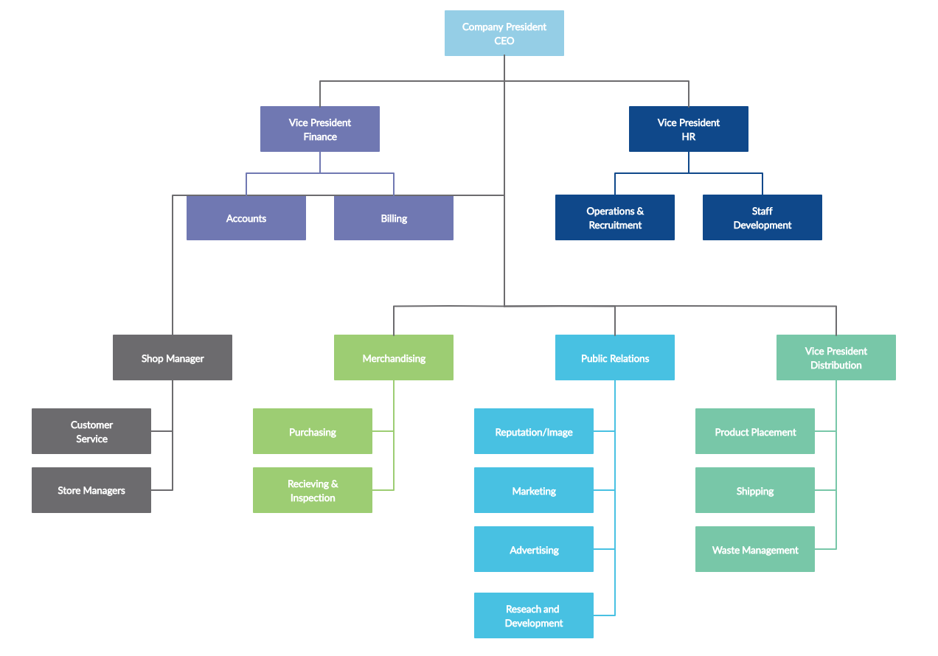

## Functional requirements

#### A. Use case diagram

#### B. Use case description

##### 1. Administrator Create Item

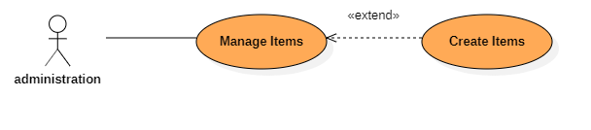

|  |  |  |  |
| --- | --- | --- | --- |
| Use Case Name : Create Items | | ID : 1 | Important Level: High |
| Primary Actor : Administration | Use Case Type : Detail, Essential | | |
| Stakeholders and Interests:  Administration — wants to create new items | | | |
| Brief Description : This use case describes how to create new items in the system | | | |
| Trigger : Administration want to create new items  Type : External | | | |
| Relationship :  Association : Manage Items  Include :  Extend : Create Items  Generalization : | | | |
| Normal Flow of Events :   1. Input all field on Create Items UI 2. System Check field input by administration 3. New Items add on database | | | |
| SubFlows:   * 1. If any field invalid, notify administration input again   2. If any field vaild go to 3. | | | |
| Alternate/Exceptional Flows: | | | |

##### 2. Administrator Update item

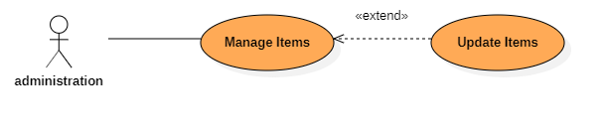

|  |  |  |  |
| --- | --- | --- | --- |
| Use Case Name : Update Items | | ID : 2 | Important Level: High |
| Primary Actor : Administration | Use Case Type : Detail, Essential | | |
| Stakeholders and Interests:  Administration — wants to update items | | | |
| Brief Description : This use case describes how to update items in the system | | | |
| Trigger : Administration want to update items  Type : External | | | |
| Relationship :  Association : Manage Items  Include :  Extend : Update Items  Generalization : | | | |
| Normal Flow of Events :   1. Choose any field want to update in UI 2. System Check field input by administration 3. Update Items on database | | | |
| SubFlows:   * 1. If any field invalid, notify administration input again   2. If any field valid go to 3. | | | |
| Alternate/Exceptional Flows: | | | |

##### 3. Administrator Delete Item

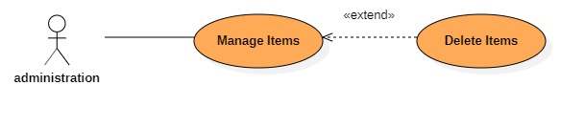

|  |  |  |  |
| --- | --- | --- | --- |
| Use Case Name : Delete Items | | ID : 3 | Important Level: High |
| Primary Actor : Administration | Use Case Type : Detail, Essential | | |
| Stakeholders and Interests:  Administration — wants to remove items | | | |
| Brief Description : This use case describes how to remove items in the system | | | |
| Trigger : Administration want to remove items  Type : External | | | |
| Relationship :  Association : Manage Items  Include :  Extend : Delete Items  Generalization : | | | |
| Normal Flow of Events :   1. Choose items want to remove in UI 2. Delete Items on database | | | |
| SubFlows: | | | |
| Alternate/Exceptional Flows: | | | |

##### 4. Administrator Searching for orders

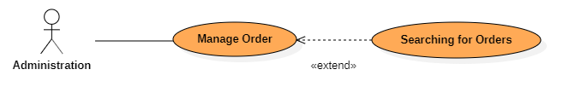

|  |  |  |  |
| --- | --- | --- | --- |
| Use Case Name : Searching Orders | | ID : 4 | Important Level: High |
| Primary Actor : Administration | Use Case Type : Detail, Essential | | |
| Stakeholders and Interests:  Administration — wants to search order of customer | | | |
| Brief Description : This use case describes how search orders in the system | | | |
| Trigger : Administration want to search orders  Type : External | | | |
| Relationship :  Association : Manage Order  Include :  Extend : Searching Orders  Generalization : | | | |
| Normal Flow of Events :   1. Input Orders ID ( Customer ID , Phone ) to searching order 2. System display all orders related input of admin | | | |
| SubFlows: | | | |
| Alternate/Exceptional Flows: | | | |

##### 5. Administrator View Order Details

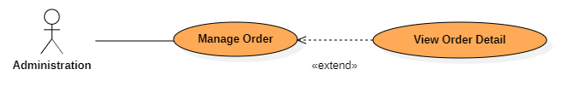

|  |  |  |  |
| --- | --- | --- | --- |
| Use Case Name : View Order Detail | | ID : 6 | Important Level: High |
| Primary Actor : Administration | Use Case Type : Detail, Essential | | |
| Stakeholders and Interests:  Administration — wants to view order detail | | | |
| Brief Description : This use case describes how view order detail in the system | | | |
| Trigger : Administration want to search orders  Type : External | | | |
| Relationship :  Association : Manage Order  Include :  Extend : View Order Detail  Generalization : | | | |
| Normal Flow of Events :   1. Input Orders ID ( Customer ID , Phone ) to searching order 2. System display all orders related input of admin 3. View Order Detail | | | |
| SubFlows: | | | |
| Alternate/Exceptional Flows: | | | |

##### 6. Administrator Update Order Status

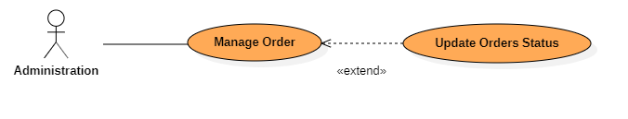

|  |  |  |  |
| --- | --- | --- | --- |
| Use Case Name : Searching Orders | | ID : 5 | Important Level: High |
| Primary Actor : Administration | Use Case Type : Detail, Essential | | |
| Stakeholders and Interests:  Administration — wants to update order status | | | |
| Brief Description : This use case describes how update order status in the system | | | |
| Trigger : Administration want to search orders  Type : External | | | |
| Relationship :  Association : Manage Order  Include :  Extend : Update Orders Status  Generalization : | | | |
| Normal Flow of Events :   1. Input Orders ID ( Customer ID , Phone ) to searching order 2. System display all orders related input of admin 3. View Order Detail 4. Change status of orders | | | |
| SubFlows: | | | |
| Alternate/Exceptional Flows: | | | |

##### 7. Adding to Shopping cart

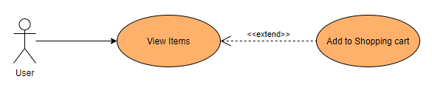

|  |  |  |  |
| --- | --- | --- | --- |
| Use Case Name : Adding to Shopping Cart | | ID : 7 | Important Level: High |
| Primary Actor : User | Use Case Type : Detail, Essential | | |
| Stakeholders and Interests:  User-Wants to add an item to Shopping cart | | | |
| Brief Description : This use case describes how the user add an item to Shopping Cart | | | |
| Trigger : Basic users want to add items to Shopping cart  Type : External | | | |
| Relationship :  Association : View Items  Include :  Extend : Adding to shopping cart  Generalization : | | | |
| Normal Flow of Events :   1. Select an item from the home page to view details. 2. Next, select the quantity of item that user want to Add to shopping cart. 3. Then Click on Adding to cart button. 4. Then System will automatically Adding user selected items to Shopping Cart 5. Finally, System will display a messages to notice that you have adding success. | | | |
| SubFlows: | | | |
| Alternate/Exceptional Flows: | | | |

##### 8. Search Item by Key-word

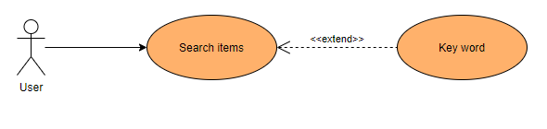

|  |  |  |  |
| --- | --- | --- | --- |
| Use Case Name : Search Items by Key word | | ID : 8 | Important Level: High |
| Primary Actor : Basic User | Use Case Type : Detail, Essential | | |
| Stakeholders and Interests:  User-Want to search for items by key word | | | |
| Brief Description : This use case describes how to Search for items in home page | | | |
| Trigger : Administration want to Search for items  Type : External | | | |
| Relationship :  Association : View Items  Include :  Extend : Search Items  Generalization : | | | |
| Normal Flow of Events :   1. Enter a key word that you want to search into Search filter. 2. Click on search button or press Enter. 3. Any items that related or contain Entered key word will be displayed to the user | | | |
| SubFlows:   * 1. If user entered keyword does not related to any items ,There is no items will be displayed   2. If user entered keyword related to at least 1 items, then go to 3. | | | |
| Alternate/Exceptional Flows: | | | |

##### 9. View Item Details

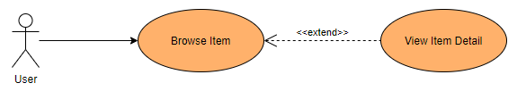

|  |  |  |  |
| --- | --- | --- | --- |
| Use Case Name : View Items details | | ID : 9 | Important Level: High |
| Primary Actor : Basic user | Use Case Type : Detail, Essential | | |
| Stakeholders and Interests:  User — wants to view item details | | | |
| Brief Description : This use case describes how to view item details in the system | | | |
| Trigger : User want to view item details  Type : External | | | |
| Relationship :  Association : Browse item  Include :  Extend : View Items details  Generalization : | | | |
| Normal Flow of Events :   1. Choosing an item that you want to view details 2. Click on View details button. 3. You will be redirect to another page that show all your selected item details. | | | |
| SubFlows: | | | |
| Alternate/Exceptional Flows: | | | |
| Use Case Name : View Items details | | ID : 3 | Important Level: High |
| Primary Actor : Basic user | Use Case Type : Detail, Essential | | |
| Stakeholders and Interests:  User — wants to view item details | | | |
| Brief Description : This use case describes how to view item details in the system | | | |
| Trigger : User want to view item details  Type : External | | | |
| Relationship :  Association : View Items  Include :  Extend : View Items details  Generalization : | | | |
| Normal Flow of Events :   1. Choosing an item that you want to view details 2. Click on View details button. 3. You will be redirect to another page that show all your selected item details. | | | |
| SubFlows: | | | |
| Alternate/Exceptional Flows: | | | |

##### 10. Giving Comment on an Item

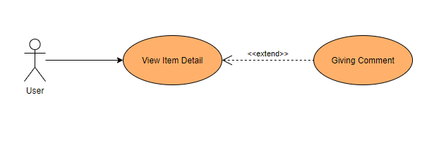

|  |  |  |  |
| --- | --- | --- | --- |
| Use Case Name : Giving comment on Items | | ID : 10 | Important Level: High |
| Primary Actor : Basic user | Use Case Type : Detail, Essential | | |
| Stakeholders and Interests:  Basic user — wants to comment on an item | | | |
| Brief Description : This use case describes how basic user giving comment on an specify item | | | |
| Trigger : User want to giving comment  Type : External | | | |
| Relationship :  Association : View Item Detail  Include :  Extend : Giving comment  Generalization : | | | |
| Normal Flow of Events :   1. After you click to view an specify item details, click on giving comment to start Commenting on an item 2. Enter your comment in the comment text area. 3. Then click on submit to upload your comment | | | |
| SubFlows: | | | |
| Alternate/Exceptional Flows: | | | |

##### 11. Searching Order

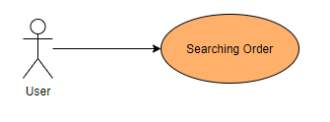

|  |  |  |  |
| --- | --- | --- | --- |
| Use Case Name : Searching Orders | | ID : 11 | Important Level: High |
| Primary Actor : Basic user | Use Case Type : Detail, Essential | | |
| Stakeholders and Interests:  Basic — wants to Search for an items by phone number | | | |
| Brief Description : This use case describes how an basic user can searching for an order | | | |
| Trigger : Basic user want to search for orders  Type : External | | | |
| Relationship :  Association :  Include :  Extend :  Generalization : | | | |
| Normal Flow of Events :   1. Click on Searching for order button in website navbar 2. Then in Searching order page, Enter phone number in text area that you want to search 3. Then ,any order that was created by your input phone number will be displayed,   You can click on View detail in each order was display to view its detail. | | | |
| SubFlows: | | | |
| Alternate/Exceptional Flows: | | | |

##### 12. Making Order

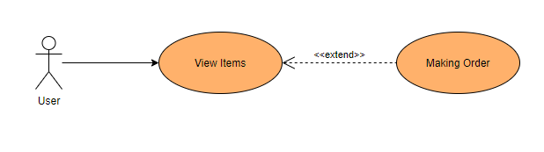

|  |  |  |  |
| --- | --- | --- | --- |
| Use Case Name : Making Order | | ID : 4 | Important Level: High |
| Primary Actor : Basic user | Use Case Type : Detail, Essential | | |
| Stakeholders and Interests:  User — wants to checkout after selected items to Shopping cart | | | |
| Brief Description : This use case describes how to making order after selected items to Shopping cart | | | |
| Trigger : User want to making order  Type : External | | | |
| Relationship :  Association : View Items  Include :  Extend : Making Order  Generalization : | | | |
| Normal Flow of Events :   1. Click on continue to Order After Selecting all items that you want to add to your shopping cart to redirect to checkout page 2. Entering your Shipping information: Receiver information, Method of payment, Shipping Address. 3. After Enter phone number for Receiver information, you will confirm your contact phone by typing your Phone verification code that you have sent throw your phone 4. Making payment. 5. Then click on checkout to confirm your order. | | | |
| Sub Flows:   * 1. If you already registered and login in to system ,your Receiver information will be extract from your profile , and your shipping address will be selected from your Shipping address list   2. If you have not yet registered and login into system, your checkout information will be took from your typing.   3.1 If you entered wrong verification code or your code time was expired, you can request for another code.  3.2 If you entered correct verification code , then go to 4 | | | |
| Alternate/Exceptional Flows: | | | |
| Use Case Name : Making Order | | ID : 4 | Important Level: High |
| Primary Actor : Basic user | Use Case Type : Detail, Essential | | |
| Stakeholders and Interests:  User — wants to checkout after selected items to Shopping cart | | | |
| Brief Description : This use case describes how to making order after selected items to Shopping cart | | | |
| Trigger : User want to making order  Type : External | | | |
| Relationship :  Association : View items  Include :  Extend : Checkout  Generalization : | | | |
| Normal Flow of Events :   1. Click on continue to Checkout After Selecting all items that you want to add to your shopping cart to redirect to checkout page 2. Entering your Shipping information: Receiver information, Method of payment, Shipping Address. 3. After Enter phone number for Receiver information, you will confirm your contact phone by typing your Phone verification code that you have sent throw your phone 4. Making payment. 5. Then click on checkout to confirm your order. | | | |
| Sub Flows:   * 1. If you already registered and login in to system ,your Receiver information will be extract from your profile , and your shipping address will be selected from your Shipping address list   2. If you have not yet registered and login into system, your checkout information will be took from your typing.   3.1 If you entered wrong verification code or your code time was expired, you can request for another code.  3.2 If you entered correct verification code , then go to 4 | | | |
| Alternate/Exceptional Flows: | | | |

#### C. Mockup/Wirefram*Main Home Page

##### View Item Details

* + - 1. 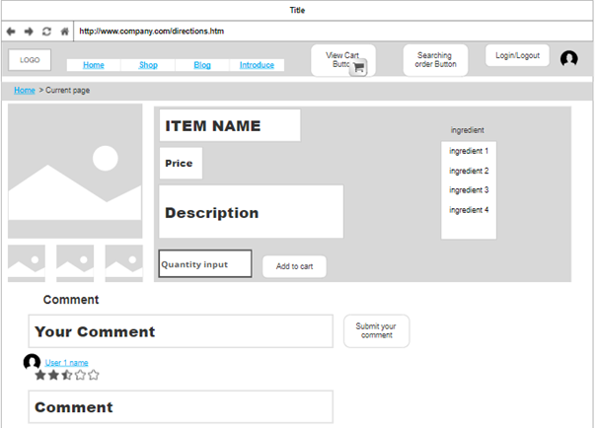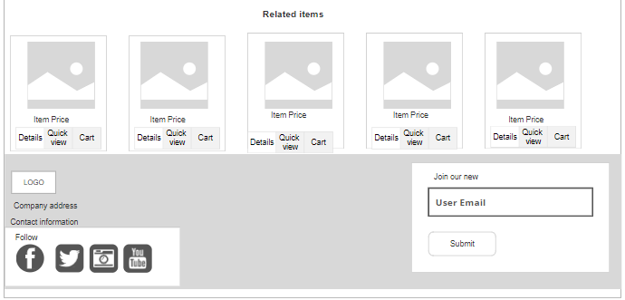

##### Create new Itemshttps://scontent-xsp1-1.xx.fbcdn.net/v/t1.15752-9/106401025_3976974815711177_2987103189333084204_n.jpg?_nc_cat=108&_nc_sid=b96e70&_nc_ohc=h8ScUi4KMFAAX8F4PLf&_nc_ht=scontent-xsp1-1.xx&oh=7d6300f2070ab51815e7db0318dc2e97&oe=5F27A923

##### View Shopping cart

* + - 1. 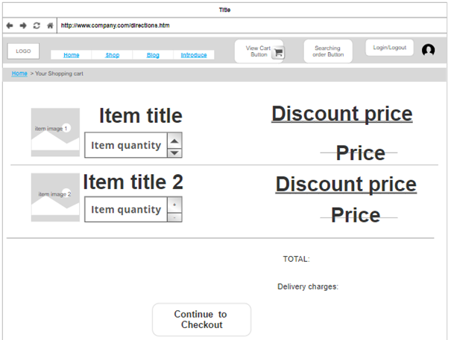
      2. 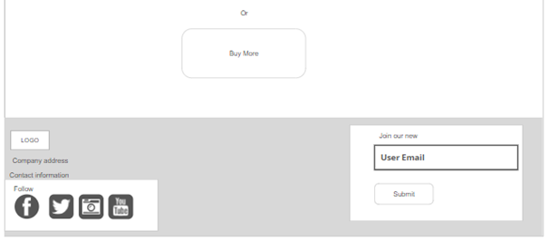

##### Checkout page

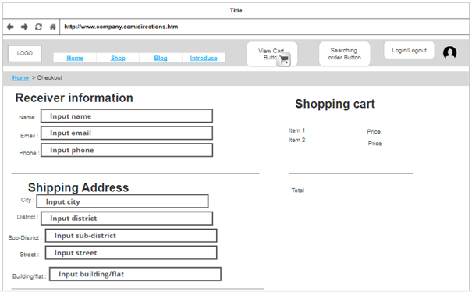

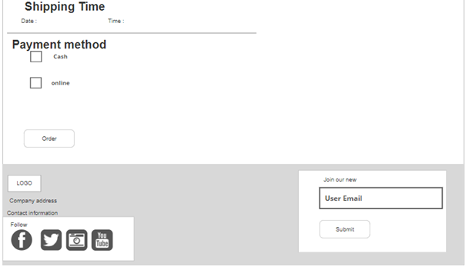

##### Update item https://scontent-xsp1-2.xx.fbcdn.net/v/t1.15752-9/75323281_594496364532750_5572460994207846107_n.jpg?_nc_cat=106&_nc_sid=b96e70&_nc_ohc=HDky4FteUdUAX_bd9-s&_nc_ht=scontent-xsp1-2.xx&oh=4fd080f232440e9469dcbcf8672cbaa5&oe=5F27B321

##### Administrator Pagehttps://scontent-xsp1-2.xx.fbcdn.net/v/t1.15752-9/106685593_3282554328501065_8786412298770606614_n.jpg?_nc_cat=100&_nc_sid=b96e70&_nc_ohc=fZMveo3f1_oAX8A3pQM&_nc_ht=scontent-xsp1-2.xx&oh=49383dc409e5f1236e0b66a1c2e6177e&oe=5F26EDBD

#### D. Business process.

##### User Activity Diagram

##### Admin Activity Diagram:

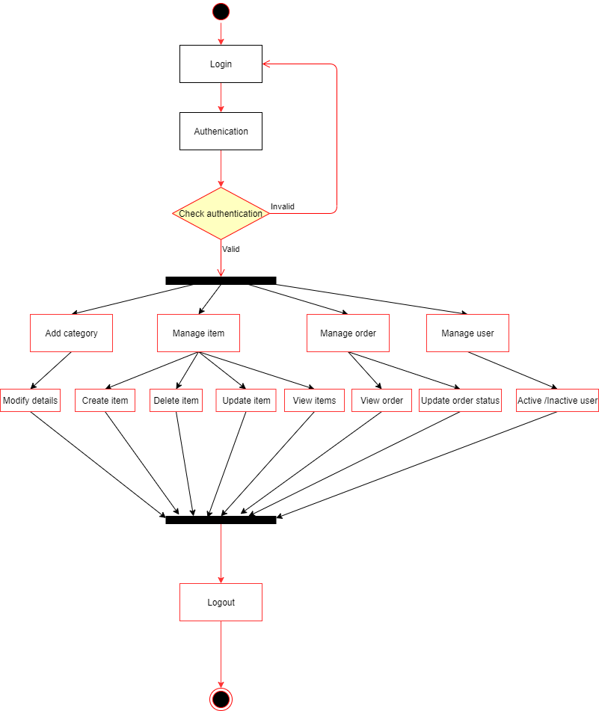

##### 3. Admin create item Activity Diagram

##### Admin update Item information

## Non-functional requirements

* Security
* The user's password must be hashed using MD5
* All "sensitive" data of users such as password, phone number, ID card, email must be encrypted with 1024bit SSL.
* When a user forgets a password, the link to create a new password must be sent to the first registered email address.
* When the user makes an online payment, the system is not allowed to store the user's credit / debit card information.
* Performance
* The number of transactions performed per second
* Allow 100 users to access at the same time
* Response time for a transaction
* Usability
* Easy to use for the first time to the website

# DESIGN SPECIFICATION

## Project Overview

## Database Design

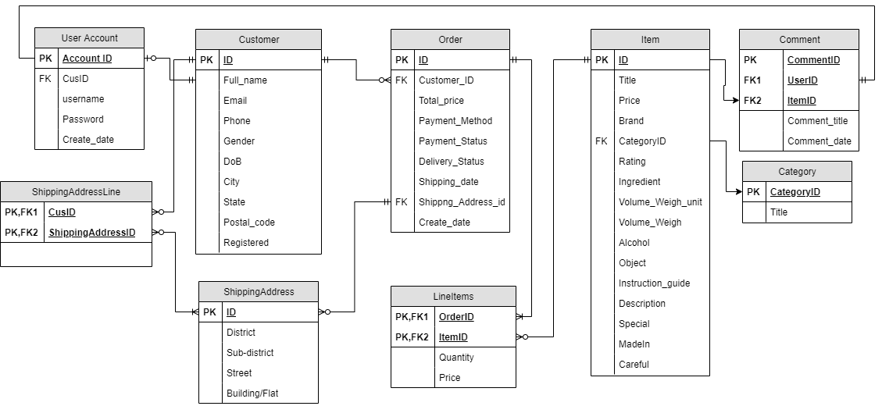

Explantation:

*Table Item:

|  |  |  |  |
| --- | --- | --- | --- |
| Attribute | Type | Explanation | Example |
| ID(PK) | String | **Identity** of Item and must be unique | Ex:1 |
| Title | String | Name of item or product | Ex: Books,333 Beer |
| Price | Number | Price of item | Ex:15.000vnd |
| Description | String | Description of an item | Ex:Sữa dinh dưỡng Vinamilk Star có đường với hương vị sữa thơm ngon, béo ngậy, dễ uống. |
| Brand | String | Brand of an Item | Ex: Sai Gon,Vinamilk |
| CategoryID(FK) | String | ID of category | Ex:1 |
| Rating | Number | Rating Number of of 5 in the bible | Ex:3.8 |
| Ingredient | String | Ingredient of item | Ex:Sữa (93,1%) (nước, sữa bột, chất béo sữa), đường (3,9%), dầu thực vật |
| Volume_weigh_unit | String | Volume or weight unit to measure item | Ex:Kg,ml,gram |
| Volume_Weigh | Number | Number of volume or weight | Ex 5kg,5ml |
| Alcohol | Number | alcohol item if item belong to alcohol drink | Ex:5% |
| Instruction_Guide | String | Instruction guide to use item | Ex:Lắc đều trước khi uống. |
| Special | String | Special point of item | EX:tinh bột nghệ dễ uống hơn bột nghệ nhiều, không bị mùi khó chịu như bột nghệ |
| Madein | String | Where made item | Ex: Việt Nam |
| Careful | String | Careful point when using item | Ex: Sản phẩm chứa các nguyên liệu có nguồn gốc từ lúa mì, đậu nành, sữa |

- Foreign Key :CategoryID references Category(ID) ,one item belong to one Category

*Table Category:

|  |  |  |  |
| --- | --- | --- | --- |
| Attribute | Type | Explanation | Example |
| ID(PK) | String | Id of category | 1 |
| Title | String | Name Of category |  |

*Table Order

|  |  |  |  |
| --- | --- | --- | --- |
| Attribute | Type | Explanation | Example |
| ID | String | iD of order | 1 |
| CustomerID(FK) | String | Id of customer who making order | 1 |
| TotalPrice | Number | Total price of order | 200.000 |
| Payment_Method | String | How Customer pay for order | Pay in cash |
| Payment_Status | String | Status of payment ,paid or unpaid | Unpaid |
| Delivery_Status | String | Status of delivery, Already or not | Delivered |
| Shipping_date | Date | Shipping date of order | 15/06/2020 |
| Shipping_Address_ID(FK) | String | Id of shipping address | 2 |
| Create_Date | Date | Date which order was created/ | 15/06/2020 |

Foreign Key :

-Shipping_Address_ID references lineitems(orderid) ,use to show detail of item in each order.

-Customer references Customer(ID), show who has making order,

-An order can have many items and an item can belong to many orders

-An customer can make many orders, and one order must belong to 1 Customer

*Table customer :Store who used to making any order in system even they Registered an account or not

|  |  |  |  |
| --- | --- | --- | --- |
| Attribute | Type | Explanation | Example |
| ID(PK) | String | Id of customer | 1 |
| Full_name | String | Full name of customer | Nguyen Quoc Dai |
| Email | String | Email of customer | 65666@gm.uit.edu.vn |
| Phone | String | Phone number of customer | 015489566565 |
| Gender | String | Customer gender ,male or female | Male |
| Dob | Date | Customer Date of birth | 14/08/1999 |
| City | String | City where they live in | Ho Chi Minh |
| State | String | Country where you come from | Viet Nam |
| Postal_code | Number | Zip postal code of where you live in | **70999** |
| Registered | String | Customer register an account on system or not | Registered |

*Table UserAccount

|  |  |  |  |
| --- | --- | --- | --- |
| Attribute | Type | Explanation | Example |
| Account_ID(PK) | String | Id of Account | 1212 |
| Cus_ID(FK) | String | Id of customer who create account |  |
| username | String | User name of account | laodai184184184 |
| password | String | Password of account after hasing | sds2s54s5d4sds189s |
| Create_date | Date | 14/06/2020 |  |

Foreign Key : Cus_id references Customer(ID) , show who create account, 1 customer can have 0 or 1 Account.

*Table Comment:

|  |  |  |  |
| --- | --- | --- | --- |
| Attribute | Type | Explanation | Example |
| CommentID(PK) | String | Id of comment | 12 |
| UserID(FK) | String | Id of user account | 2 |
| ItemID(FK) | String | Id of item which user comment on | 4 |
| Comment_Title | String | Title of comment | So beautiful |
| Comment_Date | Date | Comment date | 14/06/2020 |

Foreign Key: -UserID references UserAccount(ID) ,to show who has giving comment on an item

- ItemID references Item(ID),to show which item has comment on

*Table Shipping Address

|  |  |  |  |
| --- | --- | --- | --- |
| Attribute | Type | Explanation | Example |
| ShippingAddressID(PK) | String | Id of Shipping Address | 1 |
| District | String | District of Shipping Address | Thu Duc |
| Sub-district | String | Sub -district of Shipping address | Linh Trung |
| Street | String | Street name | Pham Van Dong |
| Building/Flat | String | House,building number | 156A |

*Table Shipping Address line

|  |  |  |  |
| --- | --- | --- | --- |
| Attribute | Type | Explanation | Example |
| CusID(PK,FK) | String | Id of customer who own shipping address | 2 |
| ShippingAddressID(PK,FK) | String | Id of Shipping Address | 3 |

## All use case

### Search items by key word

* + Class diagram

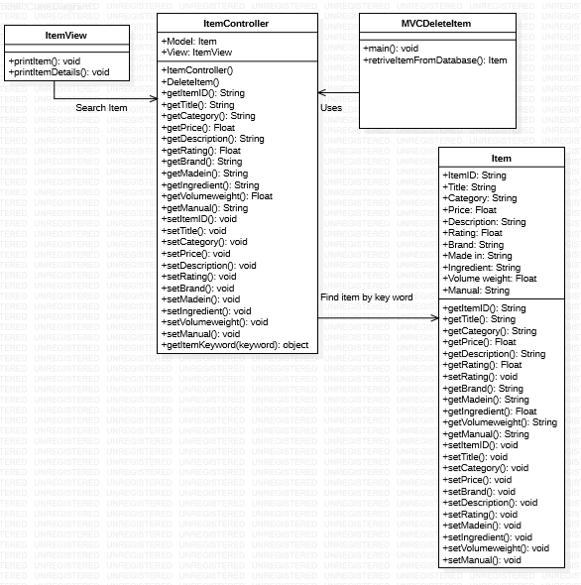

* + Sequence diagram

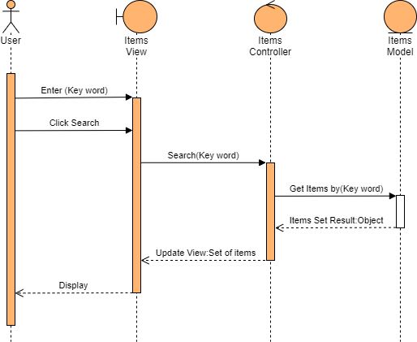

### Search items by Category

* + Class diagram

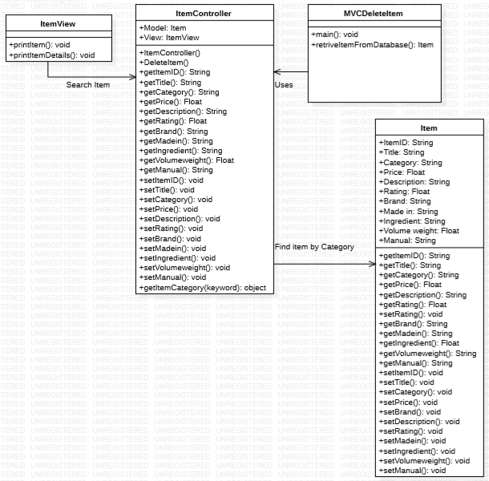

* + Sequence diagram

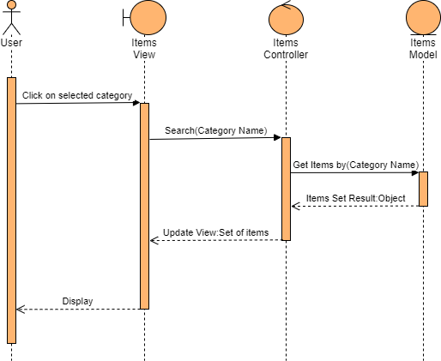

### View Item Detail

* + Class diagram

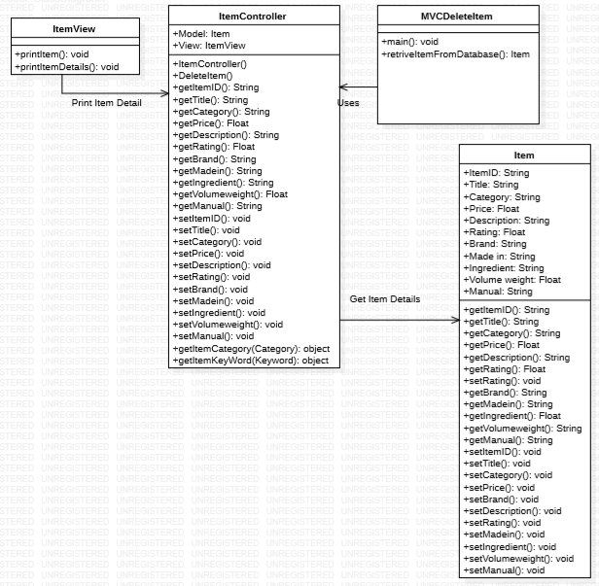

* + Sequence diagram

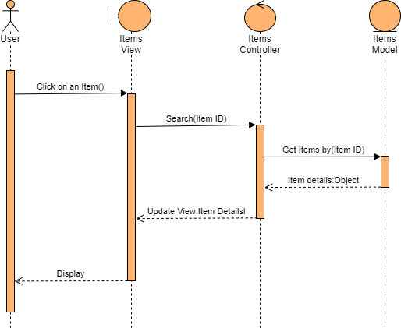

### Add item to cart

* + Class diagram

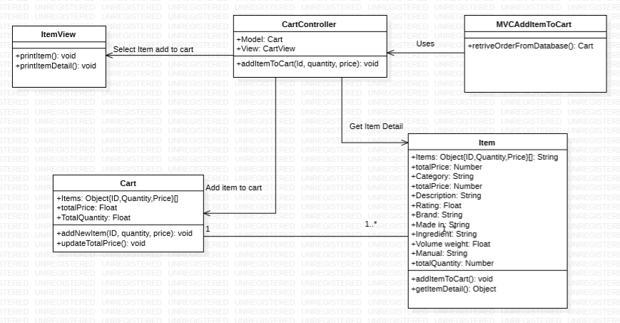

* + Sequence diagram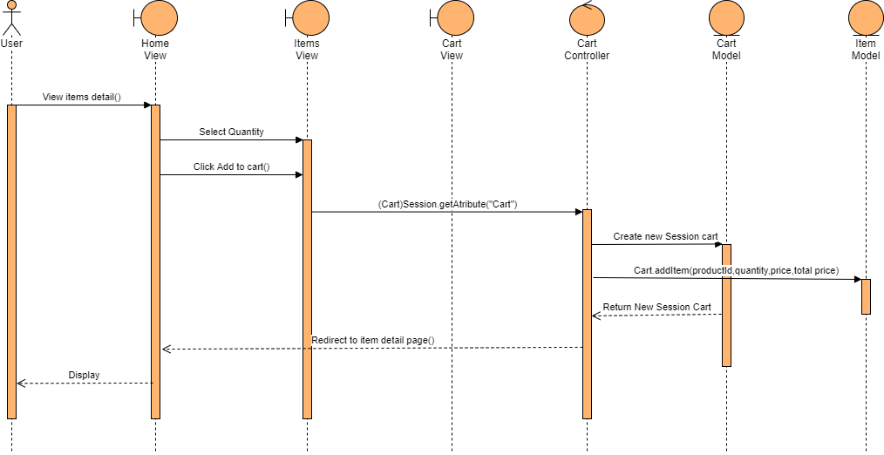

### Making order

* + 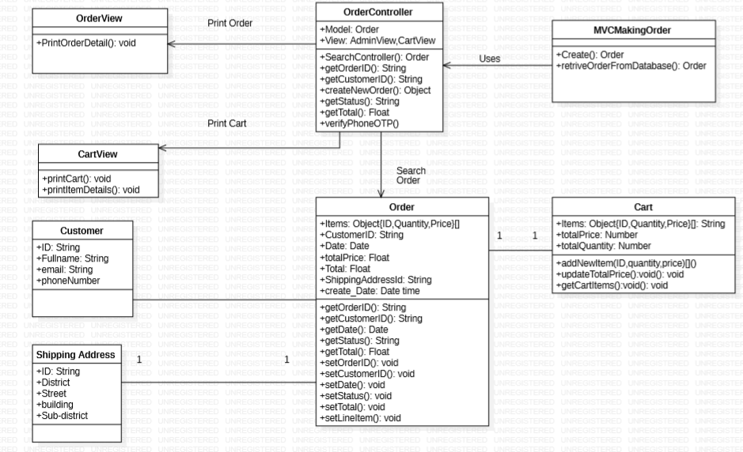Class diagram
  + Sequence diagram

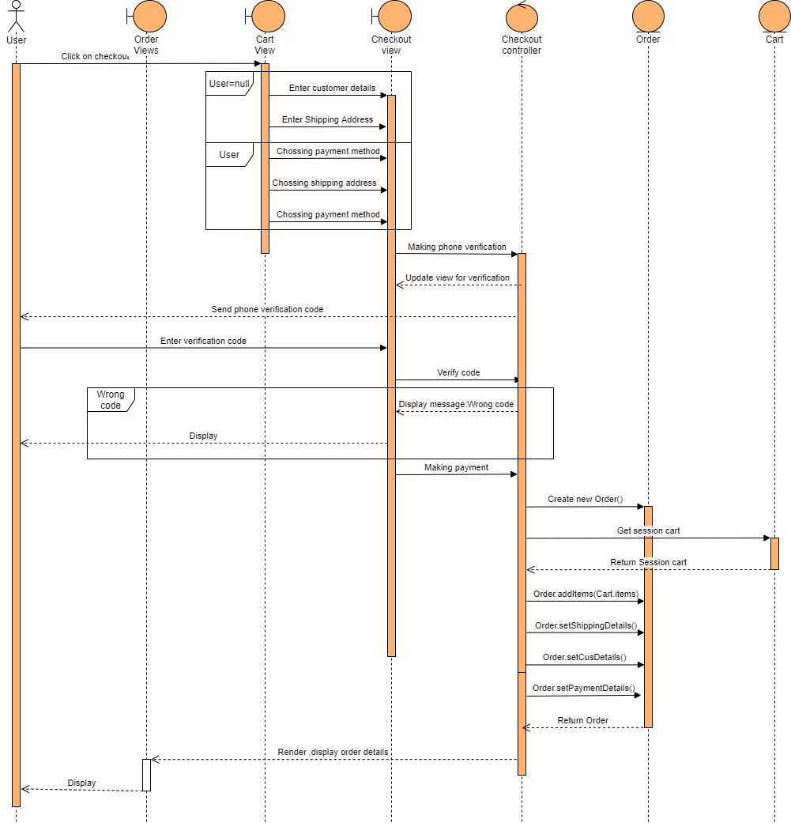

### View Shopping Cart

### Making comment in an specify item

* + Class diagram

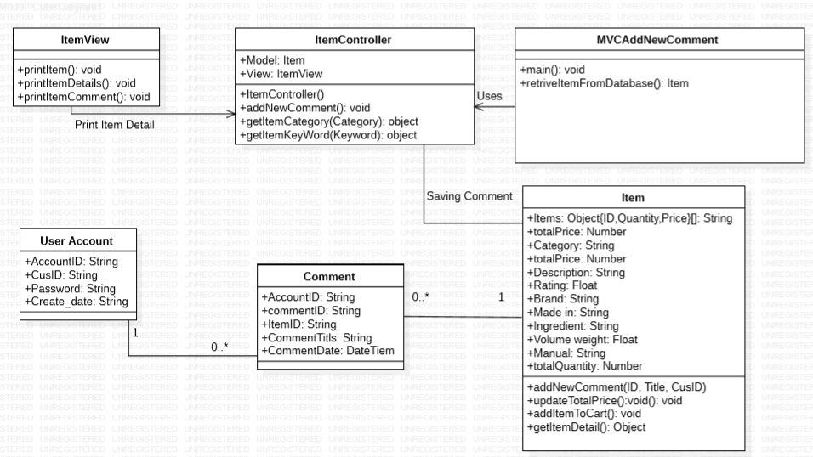

* + Sequence diagram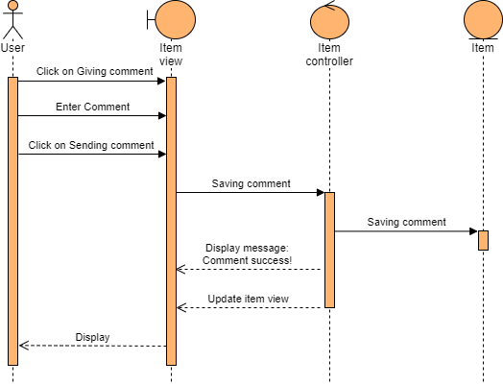

### Update user account profile

* + 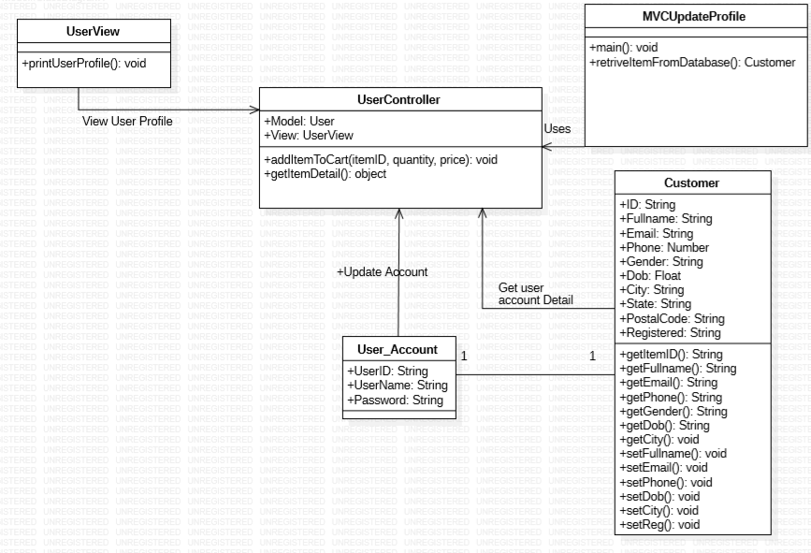Class diagram
  + Sequence diagram

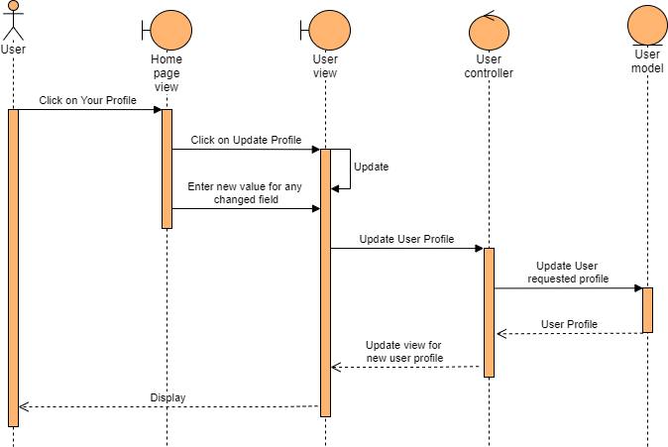

### Adding Shipping Address

* + Class diagram

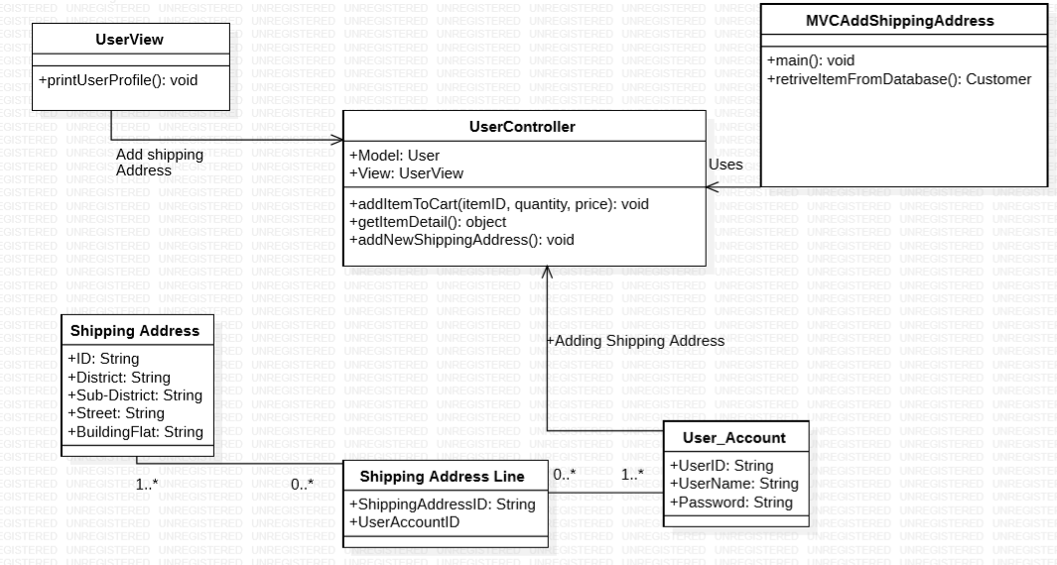

* + Sequence diagram

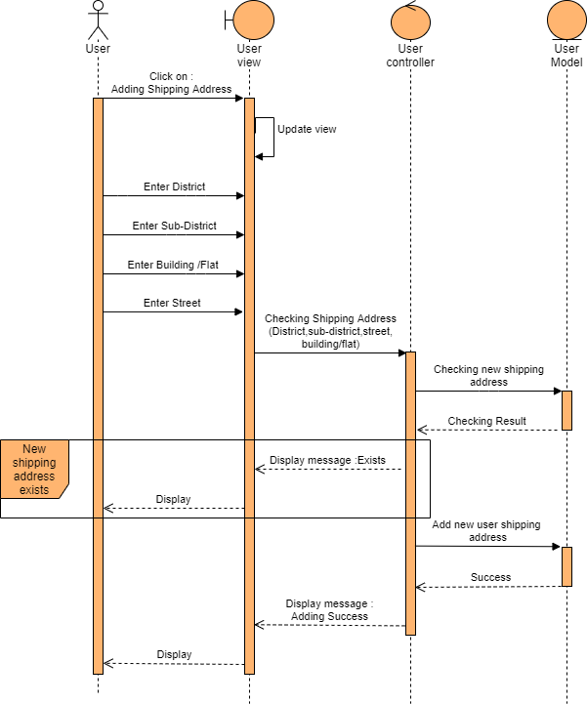

### K.Administrator Create Item

* + Class diagram

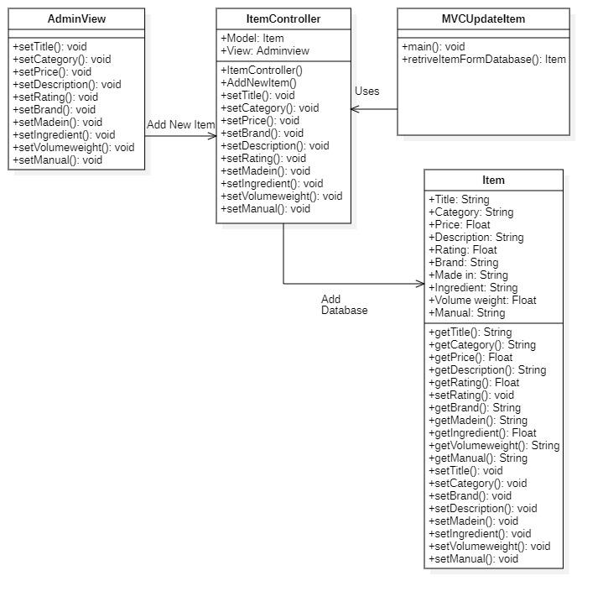

* + Sequence diagram

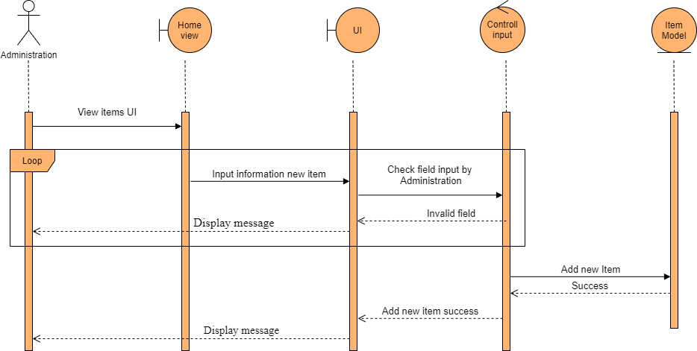

### Administrator Update Item

* + Class diagram

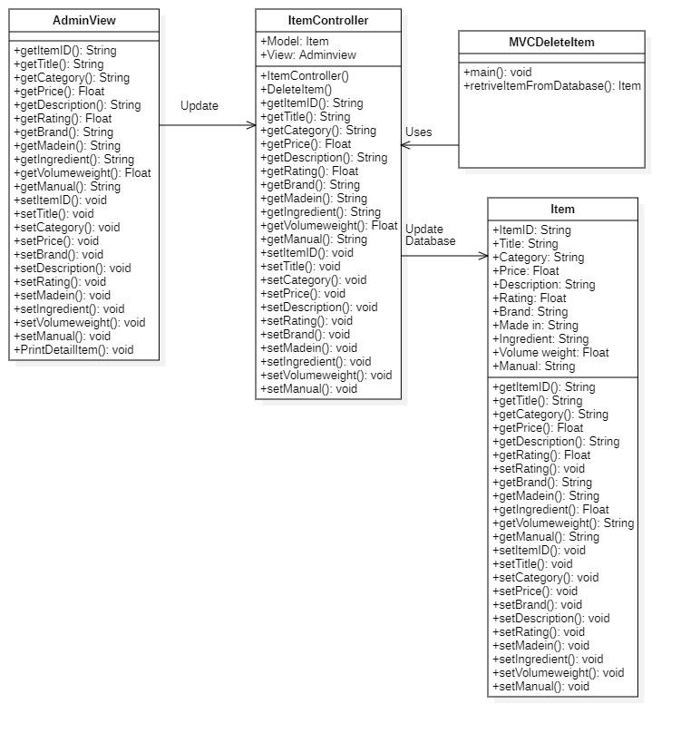

* + Sequence diagram

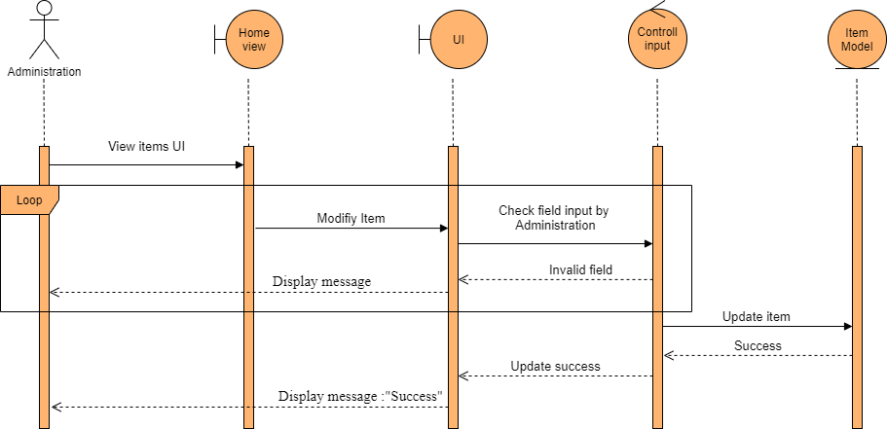

### Administrator Delete Item

* + Class diagram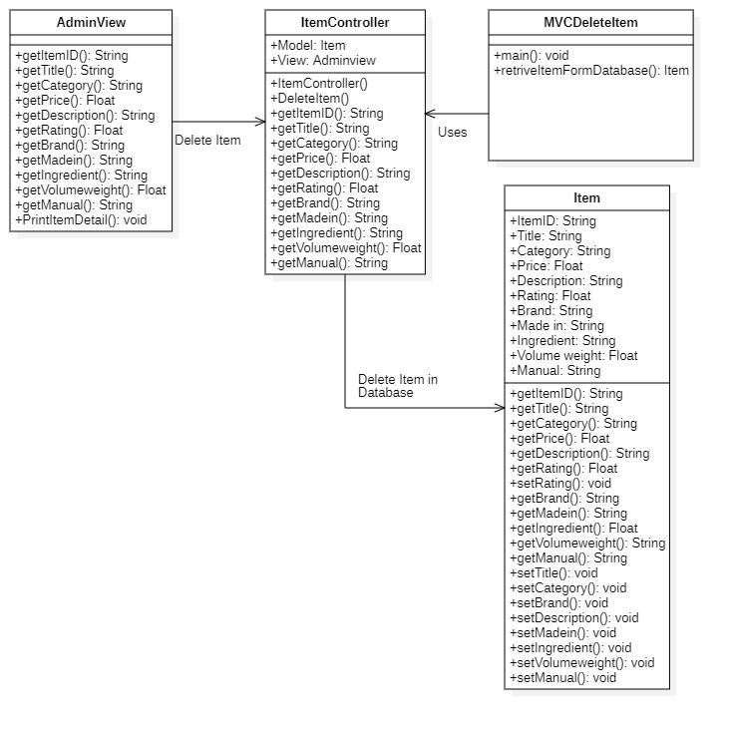
  + Sequence diagram

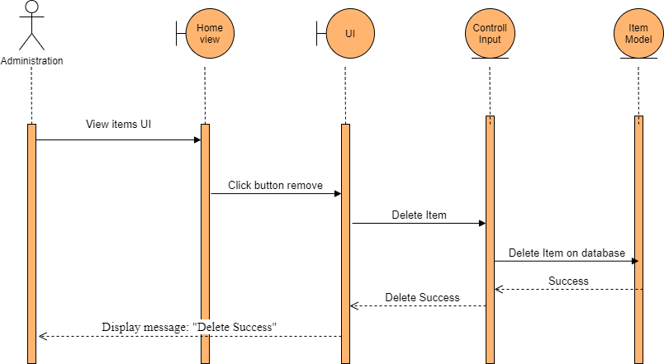

### Administrator Searching order

* + Class diagram

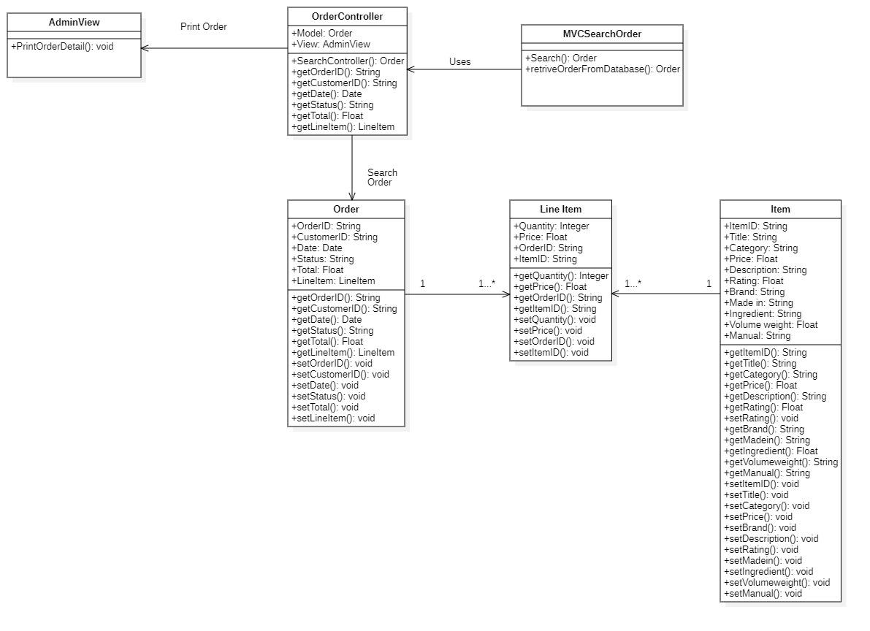

* + Sequence diagram

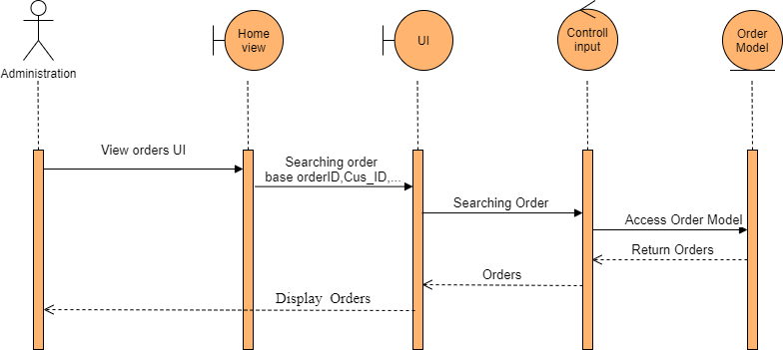

### Administrator View Order detail

* + Class diagram

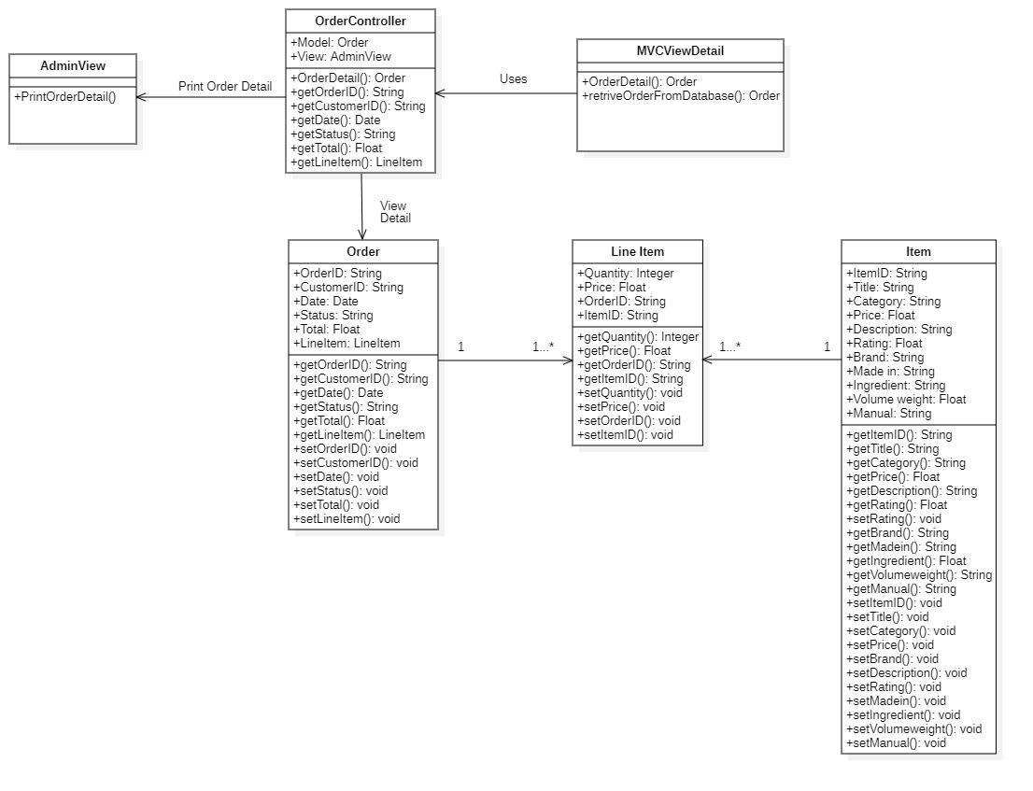

* + Sequence diagram

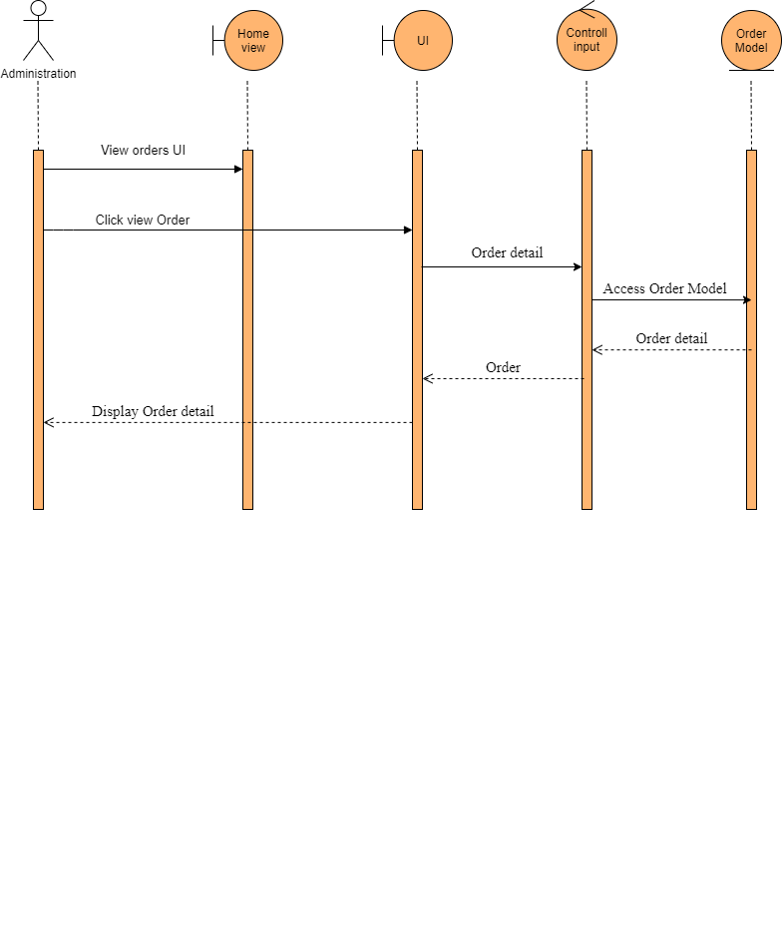

### Administrator Update order

* + Class diagram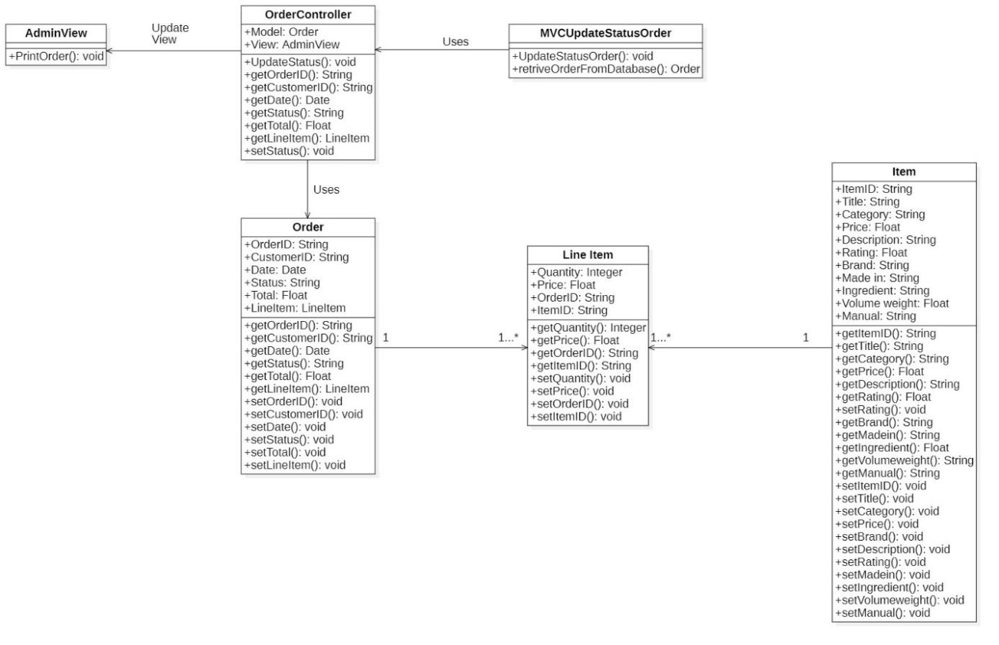
  + Sequence diagram

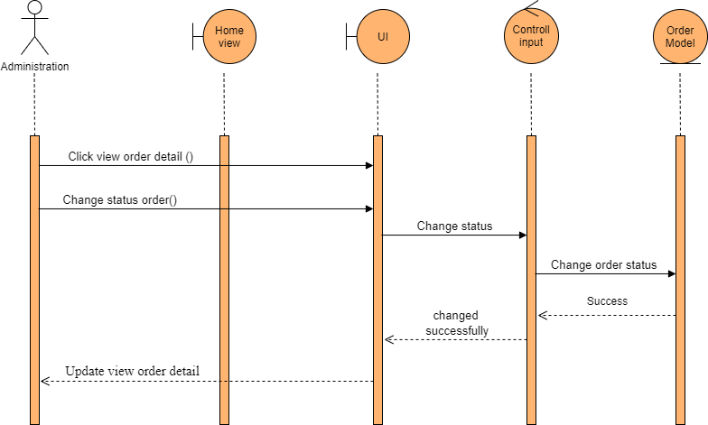

# DEMONSTRATION

## 1. System configuration

- **CPU XEON E5 2678V3**

* **RAM 32G DDR4 ECC REGISTERED ( 2x16G )**
* **SSD 1TB**

## 2. Screenshots

Home page

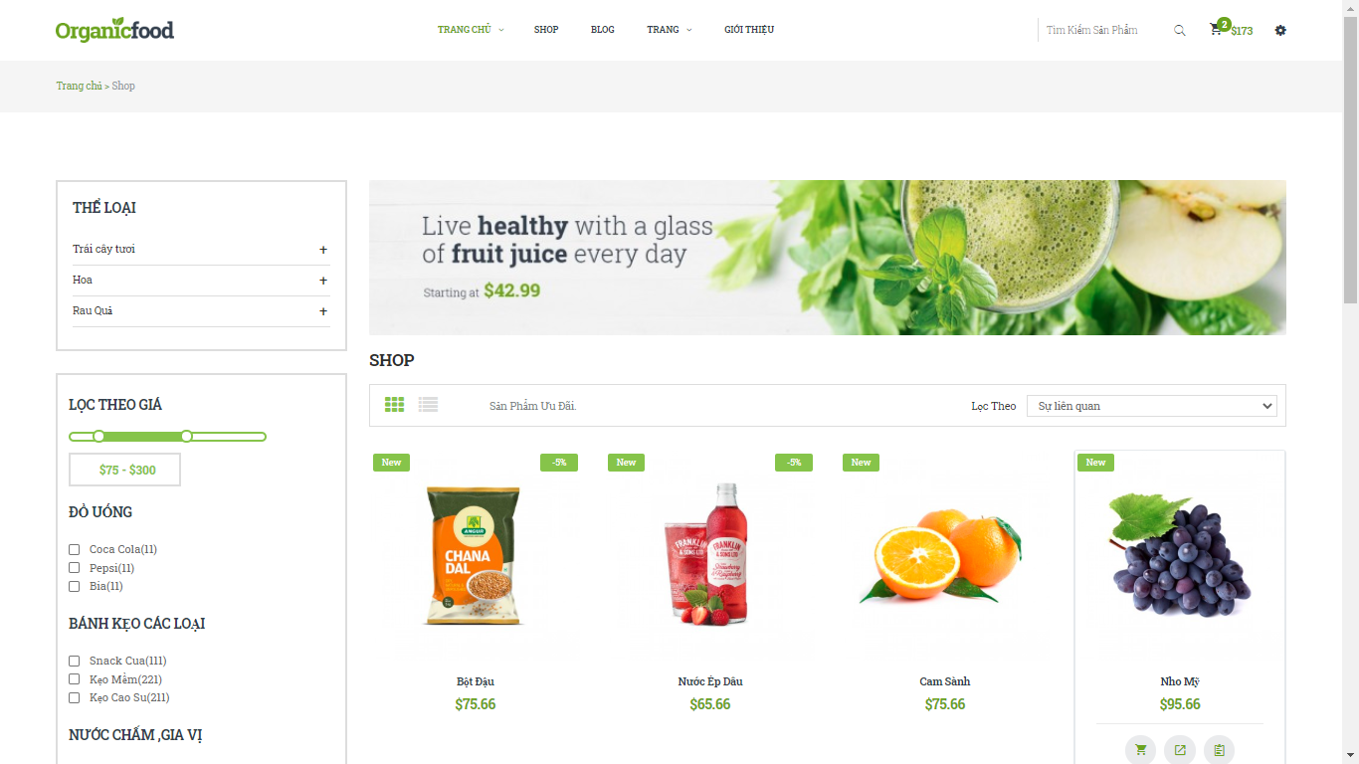

Item Detail

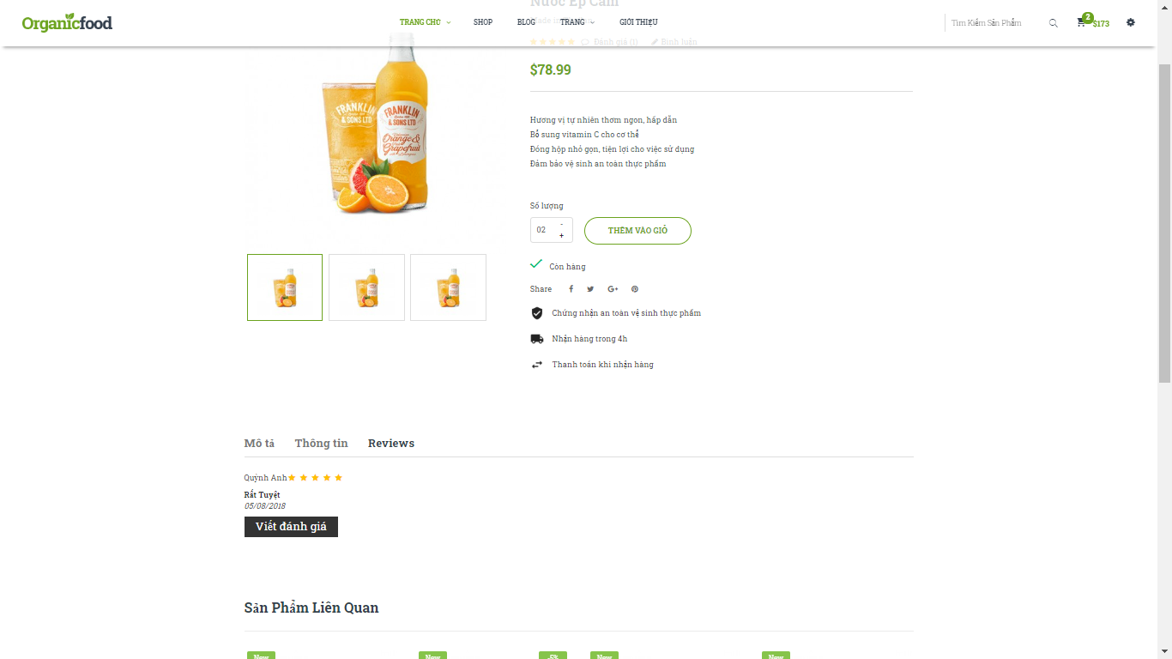

Shopping Cart

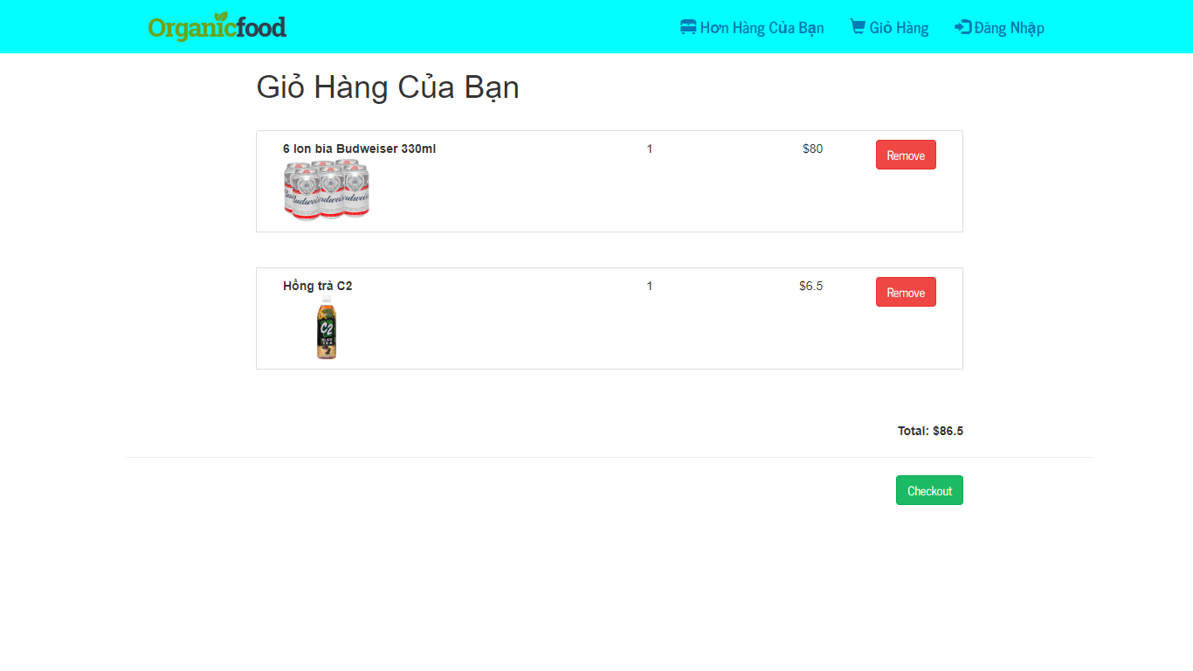

Checkout page:

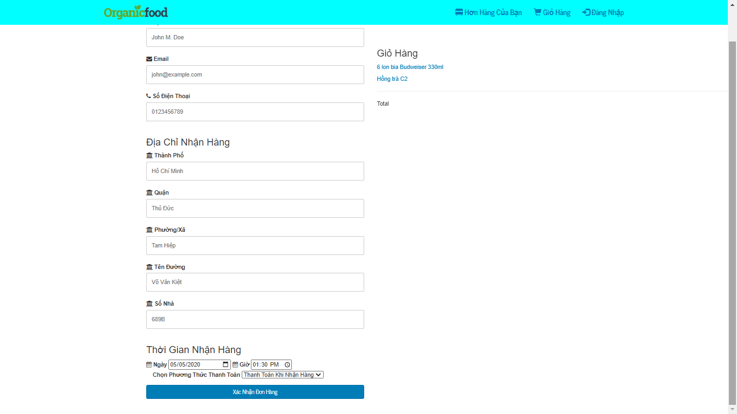

Searching order page :

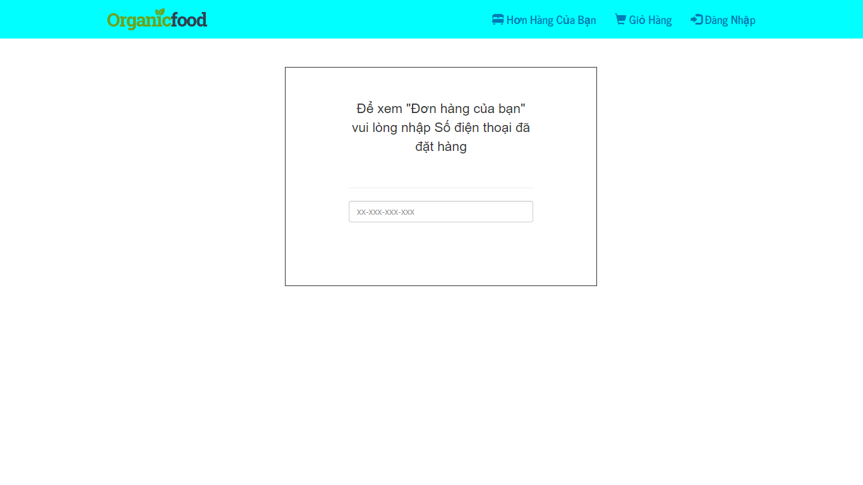

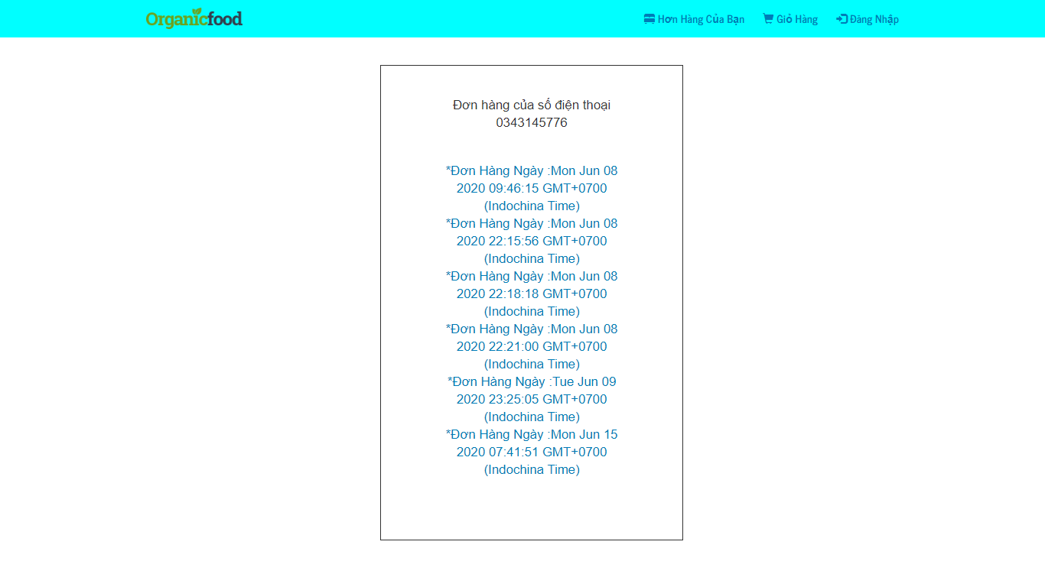Searching order results

Order Details

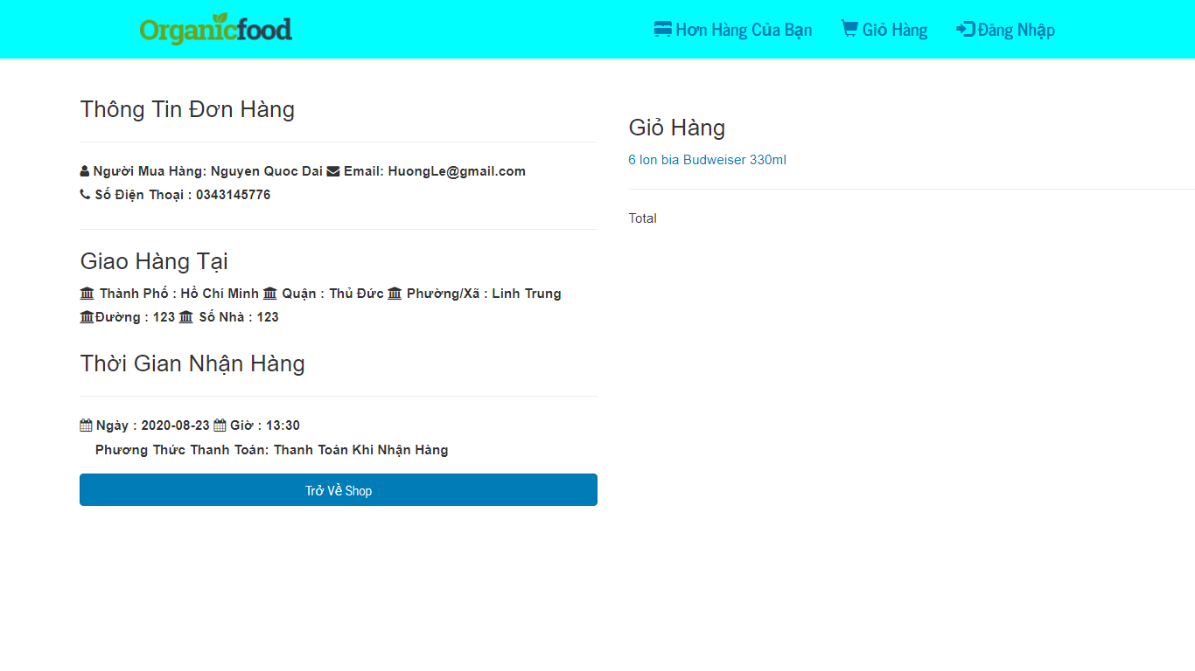

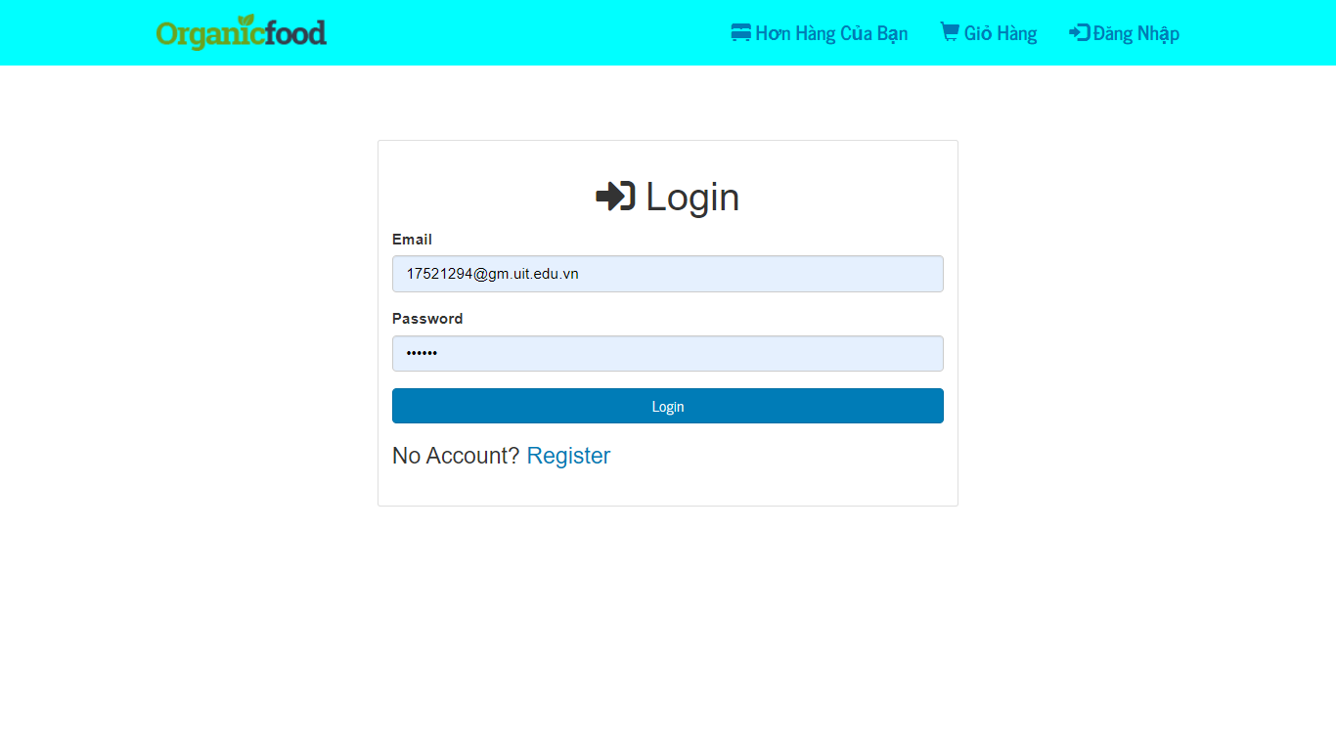Login Form

Register form

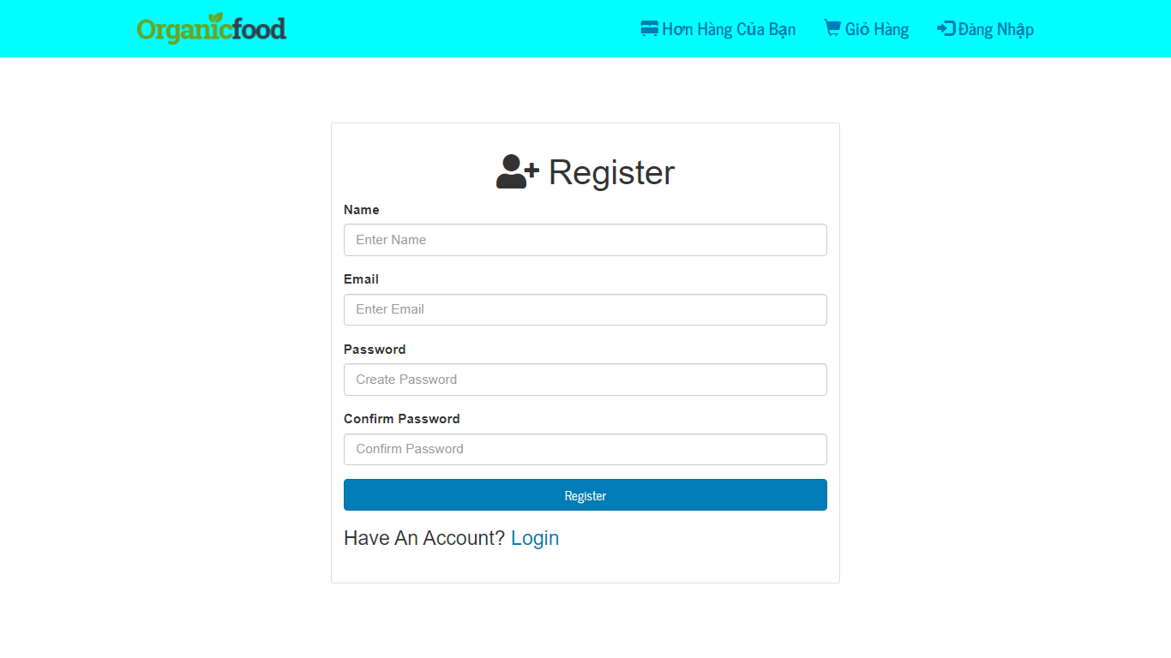

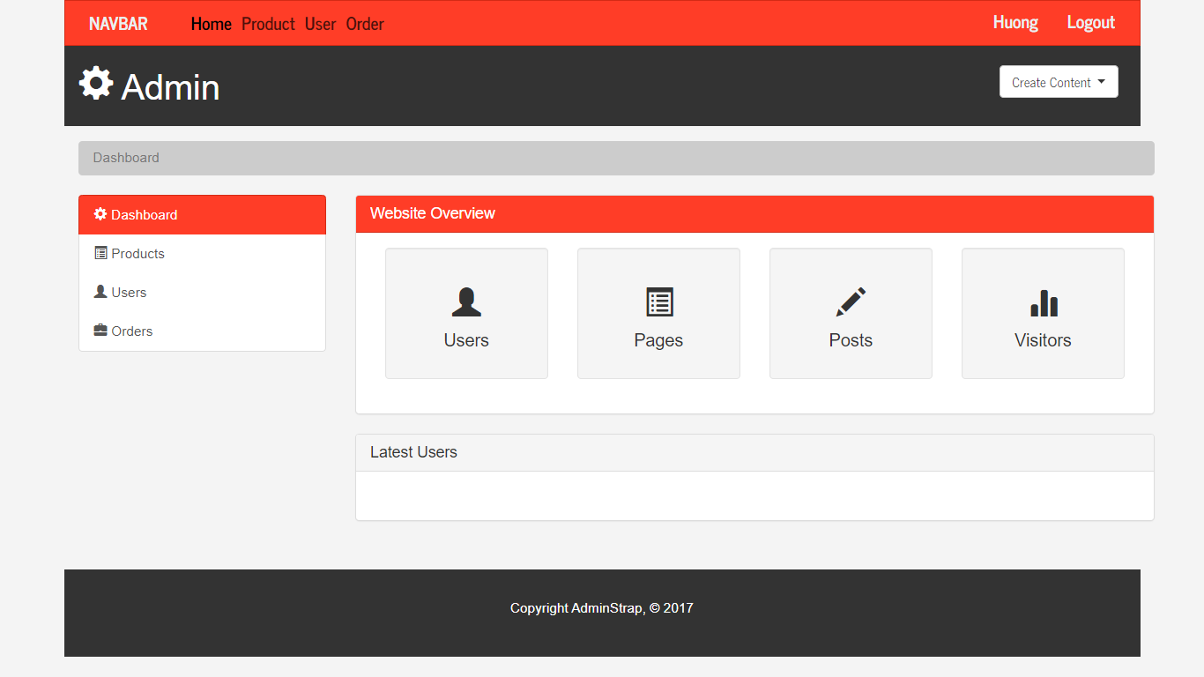Admin Page

Admin view All Item

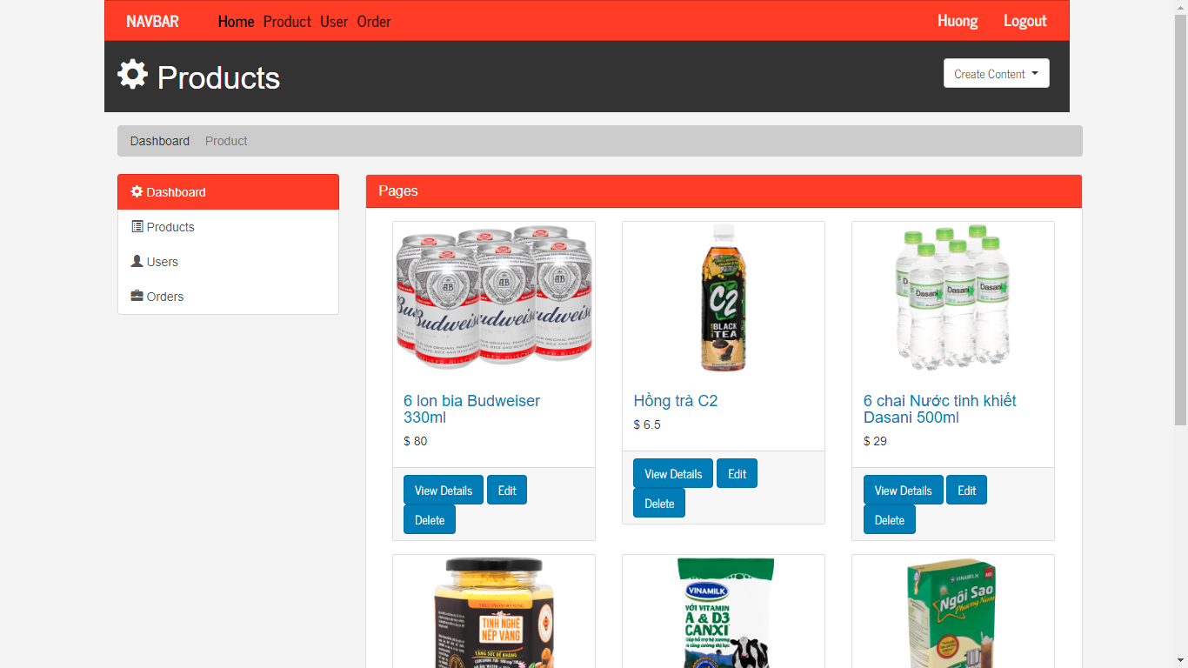

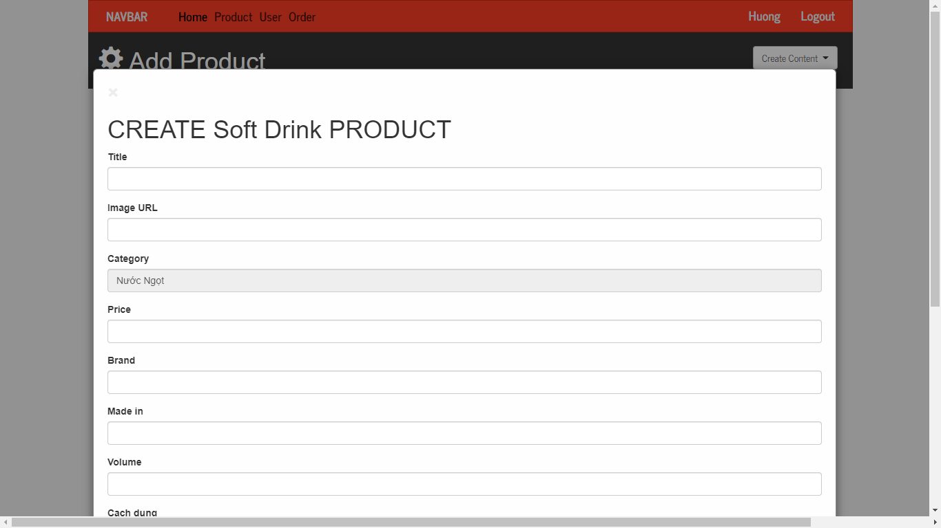Admin create new item

Admin page view order

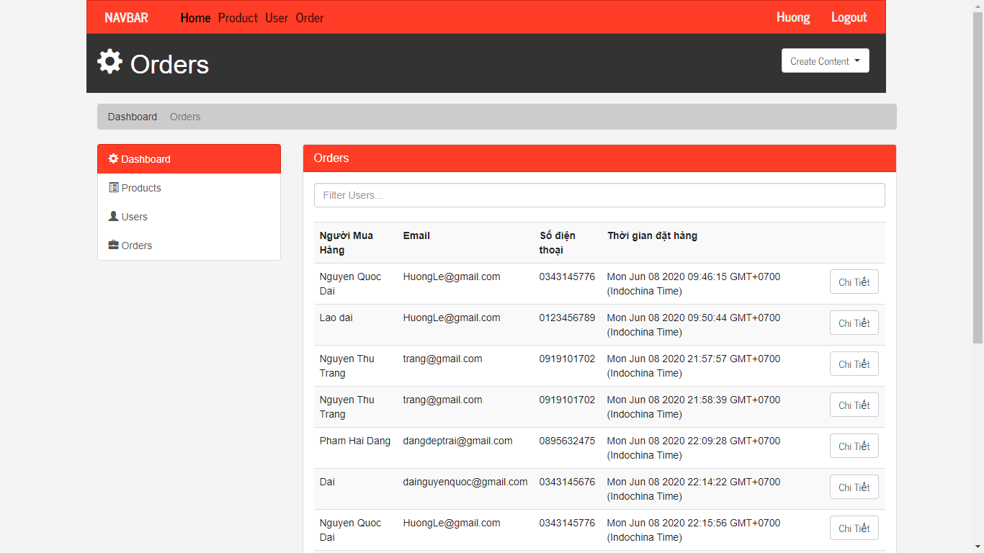

# SUMMARY

1. Achievements

* An online sales website
* Instruction document

1. Future works

* Build the system on mobile app
* Supermarket search function nearest the current location
* Switch to another language
* Social media link

Reference : <https://www.rsisinternational.org/journals/ijrsi/digital-library/volume-5-issue-3/14-18.pdf?x49905&fbclid=IwAR0pE1t1KnpsPvnMgDqZ3KORx7PMm2B_6KQ-R8vErc_wUGDGeRRYDGnc-8k>

End Of Report